**LAB # 11**

**Introduction to Test Suite**

**OBJECTIVE:** Grouping the multiple JUnit test cases and constructing a Test Suite program.

**Lab Task:**

Make a class having four functions for determining,

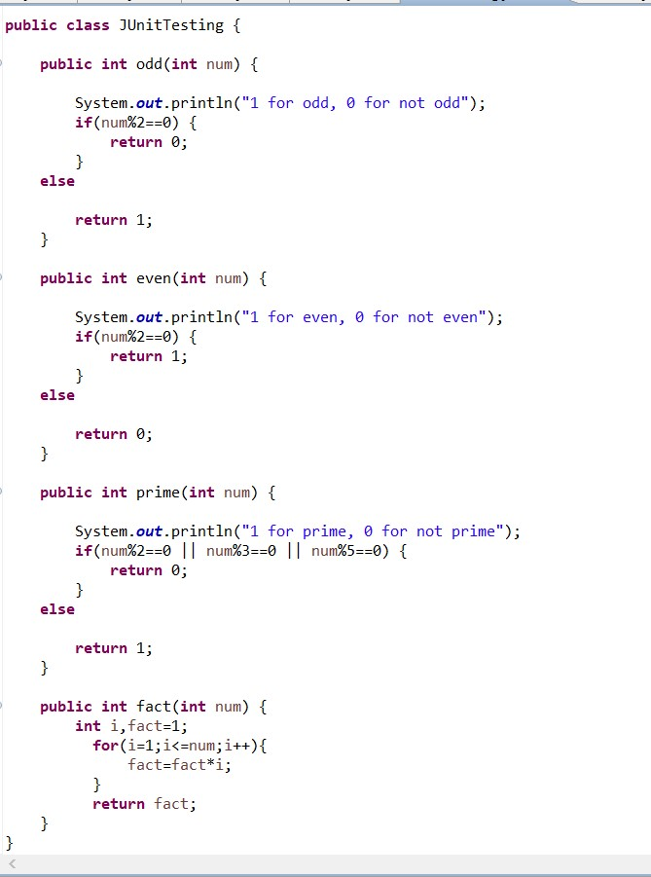

* 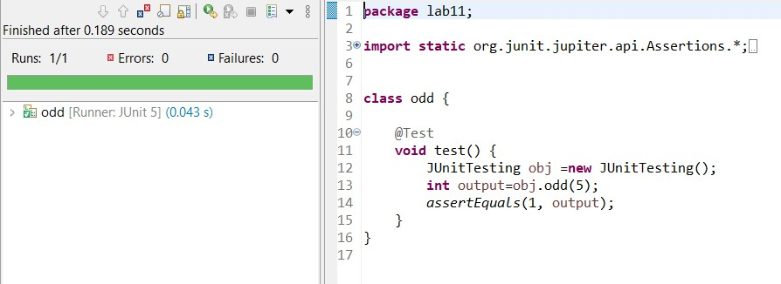Whether the input integer is odd.
* Whether the input integer is even.

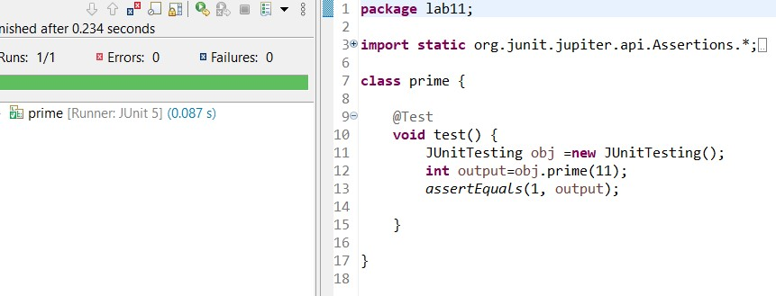

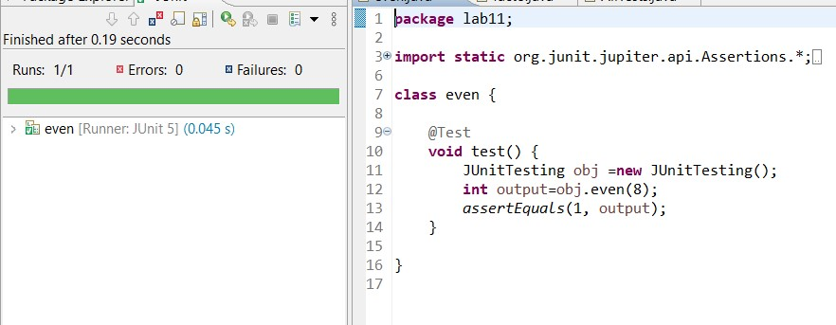

* Whether the input integer is prime.
* For calculating the factorial of that input integer.

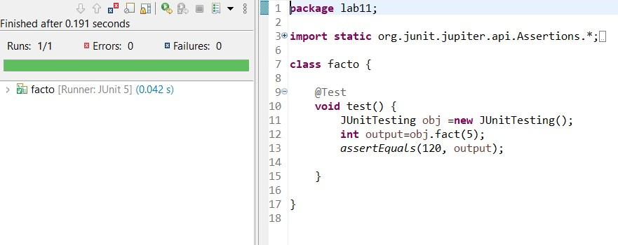

Write their test cases and execute them in a single test suite class. Follow all the steps mentioned above in the manual.

